ENABLING SERVICE

EXCELLENCE

THROUGH

ACUTE

AI PLATFORM

MACHINE LEARNING AND ARTIFICIAL INTELLIGENCE

**Intelligent automation is one of today’s most exciting technology trends. It’s a trend that takes many forms. Whether it’s seen in natural language processing, machine learning, ‘bots’, knowledge representation or other forms of artificial intelligence, it’s all aiming at a common goal: to amplify the potential of people to get work done intelligently. And it’s becoming a very big deal.**

**As the trend has taken hold around the world, the underlying technologies like machine learning have also been evolving. Although machine learning algorithms have been in use in one form or another for a long time, they have undergone something of a revolution in recent years. They now have the ability to automatically apply complex mathematical calculations and pattern recognition to big data with vastly improved speed and accuracy. And high-performing organizations are already harnessing machine learning capabilities to transform the way their employees work and create new categories of jobs. In the process, those organizations are rethinking what they do across every area of the enterprise – from business processes right through to customer experiences.**

**Front-line customer support is a particularly promising area. And leading enterprises are already pinpointing how to make the most of intelligent automation in support of their customers. We know, for example, that machine learning techniques based on pattern recognition work best with targeted use cases that leverage lots of rich contextual data. This suggests that organizations using integrated platforms for end-to-end service management are likely to benefit most from the technology. That’s because data and information often flow through different functions of a service organization required to provide customer support. And this data, along with the machine learning applied to it, is what enables an enterprise to evolve from the traditional break-fix model to a more customer-centric and cost-predictive service model. Simply put, machine learning enhances productivity and augments the way people do their work. And the resulting impacts, from reducing service costs to improving customer experience, are huge.**

**ACUTE (Auto Categorization, Triage & Enrichment) platform harnesses machine learning and pattern recognition to automate the work of service desk respondents, bringing new levels of speed and efficiency to service organizations.**

**In producing this report, we have quantified the opportunity and assessed the effectiveness of ACUTE. To do so, we modelled a scenario for a typical front-line customer support function. We used accuracy and coverage results from ServiceNow’s customer pilot program, together with some conservative assumptions, to assess the impact. The result: an impressive ROI of 42 percent, with benefits exceeding $100,000 over three years and a payback period of just 10 months. In addition, the pilot program also demonstrated that the average customer can expect an estimated time savings of approximately 8 percent (or more than 26,500 hours per year).**

THE OPPORTUNITY:

CREATING BETTER

CUSTOMER EXPERIENCES –

AT A LOWER COST

**In any typical front-line customer support function, customers use many different channels – telephone, web-chat, and email, a service catalogue – to raise issues, ask questions and make requests. Although machine learning solutions are increasingly being used behind the scenes for some of these channels (in web-chats and emails or example), this remains for the most part a human-intensive process. So, when a customer makes contact, the resulting unit of work is usually converted to an electronic record (often called a ‘*ticket’*) and employees, whether service desk agents or customer service agents, are tasked with first triaging and then managing these tickets through to closure. Ideally, they do so quickly, effectively, and without requiring the help of more expensive resources**.

**Inevitably, some tickets can’t be resolved by the agent on their own and require additional help. This is where the agent must decide where to route or assign the ticket. Sometimes this is a relatively simple decision, but many service organizations have complex delivery ecosystems, with large numbers of assignment groups. The decision is therefore not always straightforward.**

**Any organization in which front-line customer support staff are spending a lot of time making decisions about ticket categorization, prioritization and assignment is incurring excessive costs and negatively impacting the customer experience. Indeed, recent research indicates that front-line customer support functions spend approximately 12 percent of their time categorizing, prioritizing and assigning tickets. It’s therefore easy to see opportunities for improvement and where machine learning could help.**

**TO ILLUSTRATE THIS, RECENT RESEARCH HIGHLIGHTS**

**THE POTENTIAL SCALE OF THE PROBLEM. IT FOUND THAT:**

43%**of IT service desk respondents and 27 percent of customer service desk respondents had more than 100 different assignment groups to choose from and nearly a quarter of IT respondents faced a choice from more than 300 groups;**

21%**of IT service desk respondents** **and 15 percent of customer service desk respondents had more than 100 categories to choose from with more than 10 percent of IT respondents facing a choice from over 300 categories.**

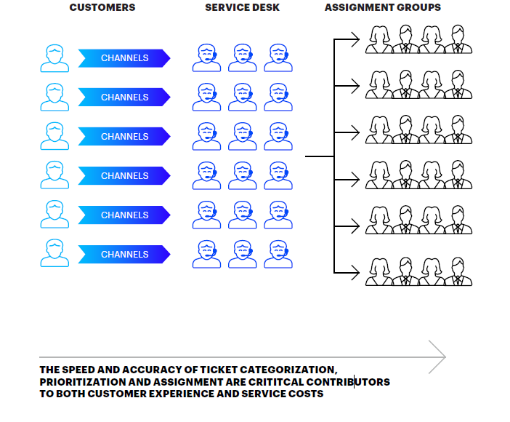

**Machine learning techniques based on pattern recognition work best with targeted use cases that leverage lots of rich contextual data. This means that service organizations that use integrated platforms, such as ServiceNow, BMC Remedy, for end-to-end service management are likely to benefit most from the technology. That’s because data and information often flow through – and are enriched by the different functions of a service organization required to provide end-to-end customer support.**

**The challenge for front-line customer support staff is that they are unable to see meaningful patterns within these huge volumes of data. It is often difficult for them to determine the right category, priority and assignment group for a specific ticket, even if it’s a repeatable task like a server reboot. The individual customer context is vital. Understanding this context often takes time and is complicated by the fact that every individual will approach the question in their own way, based on their particular skills, experience, institutional knowledge and time pressures.**

**This is where machine learning is extremely powerful. In many cases, the context of a particular ticket is already represented in data that exists within an integrated service management platform. Machine learning can effectively leverage these huge volumes of data to automate work based on the collective experience and wisdom of the whole system, rather than any one individual. Models can thus be generated to predict the output based on a given input and fine-tuned by humans to improve accuracy, coverage and error handling. Machine learning is ideal in such cases since it is as efficient at processing 10 tickets as it is at processing 10,000 tickets.**

**THUS, WHEN MACHINE LEARNING IS APPLIED TO THE CATEGORIZING,**

**PRIORITIZING AND ASSIGNING OF TICKETS, A SERVICE ORGANIZATION CAN**

**DERIVE THE FOLLOWING BENEFITS:**

